Inspection Date | 27-2-2023 | Report Walkthrough. | MACINS06 27/2/2023
Site Name | Main Campus | Location | Building D
Inspected By | Navaz | Witnessed by

Inspection Type | General Housekeeping & Sanitation Fire Electrical Ladders Lab Food Structure Motor Vehicles Landscaping PPE Stores Emergency Evacuation

S/N | Description | Risk Evaluation
 |  | Low | Med | High
 | Distribution box in electric room D05039 found not covered.
 | One of lights not working in IDF room D05040
 | Cigarette butts found in fourth floor (attached photo) -4th floor
 | Exit light not working in the corridor -4th floor near male wash room
 | Protruding steel channels may cause injury to passer-by -4th floor
 | Housekeeping not done in one of the room.
 | Schuko socket /adapter not used in indoor basket ball court -4th floor D04101
 | The mobile of contractor was found to be charging in Electric room D02044
 | Fire extinguisher found hindered in shell & core are in 2nd floor
 | There is difficulty in opening fire extinguisher cabinet door near D01051A
 | Trolley found kept in GF D Bldg Electrical room.

Attachment | √ Photos Video Footage Other

S/N
 | Action | By Whom |  | By When
 | Distribution box in electric room D05039 to be covered. | FM-Hard | 15-3-23
 | One of lights that is not working in IDF room D05040 to be replaced. | FM-Hard | 15-3-23
 | Cigarette butts found in fourth floor (attached photo) -4th floor to be removed | FM-soft | 15-3-23
 | Exit light not working in the corridor -4th floor near male wash room to be rectified | FM-Hard | 15-3-23
 | Protruding steel channels may cause injury to passer-by -4th floor to be removed | FM-Hard | 15-3-23
 | Housekeeping to be done in one of the twin room. -4th floor ( see photo) | FM-soft | 15-3-23
 | Schuko socket /adapter to be used in indoor basket ball court -4th floor D04101 | FM-Hard | 15-3-23
 | Electric room D02044 to be secured | FM-Hard | 15-3-23
 | Easy access to be provided for Fire extinguisher in shell & core area in 2nd floor | FM-soft | 15-3-23
 | Easy opening of fire extinguisher cabinet door near D01051A to be ensured | FM-Hard | 15-3-23
 | Trolley in the corridor of electric room to be removed. | FM-soft | 15-3-23

Attached Photos
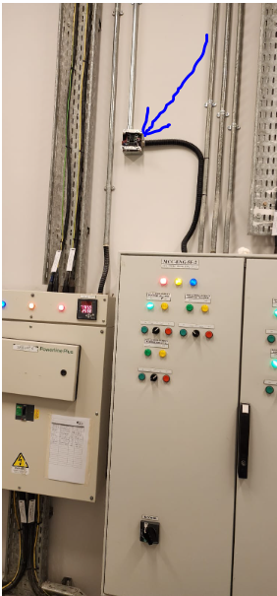 | 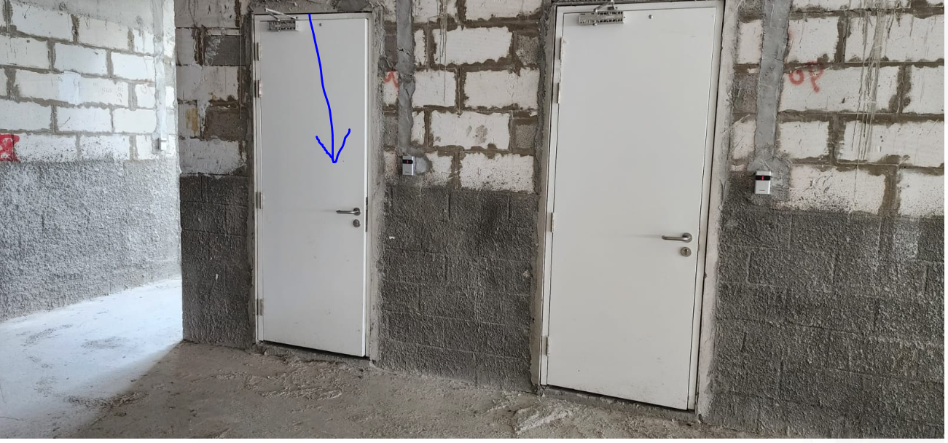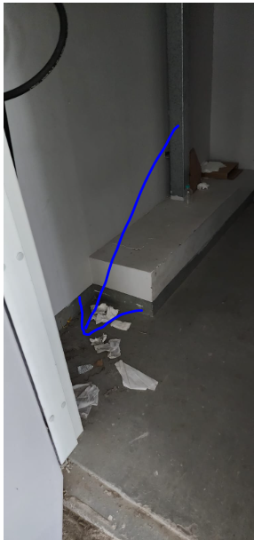 |  | 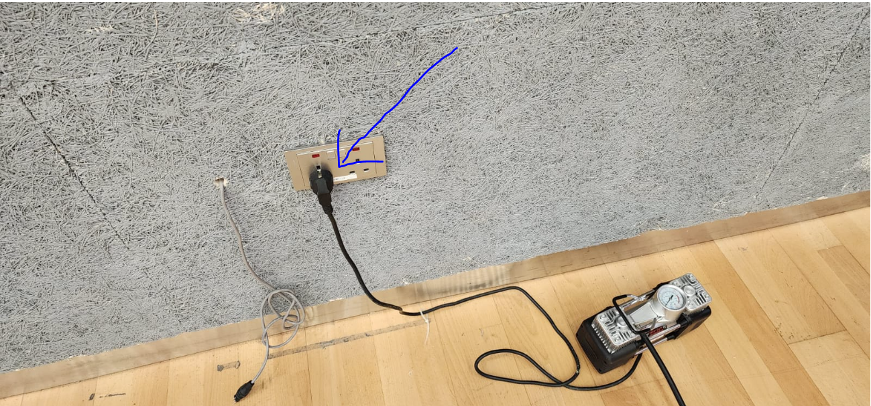
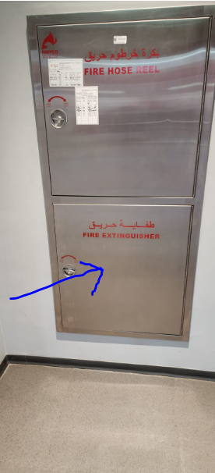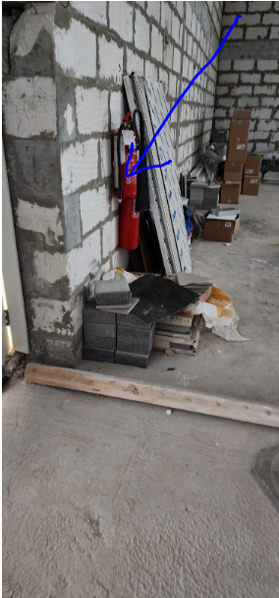 |  | 